**TECHNOVISION CABLE NETWORK KARUNAPURAM**

This is an example for BSNL broadband online payment.

1.Click on the given link-<https://portal2.bsnl.in/myportal/cfa.do>

2.Click on menu and select Landline

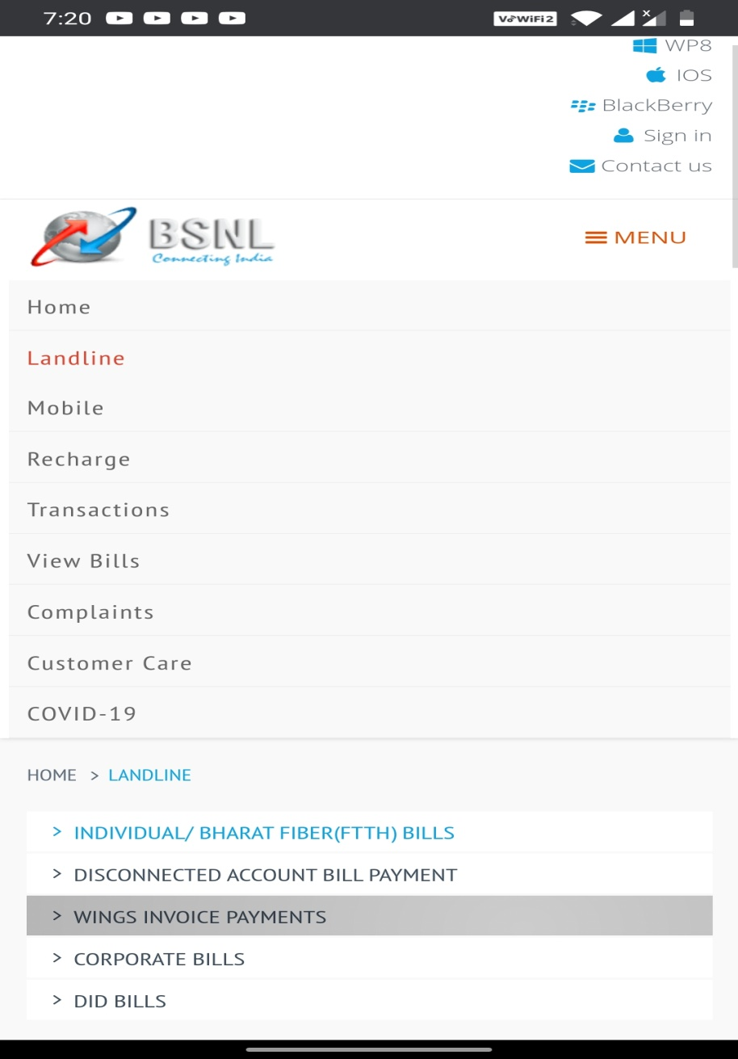

3.Enter the phone number which is provided by the BSNL(Phone numbers of each customer given on last screenshot).Then enter the email id and your own 10 digit number.

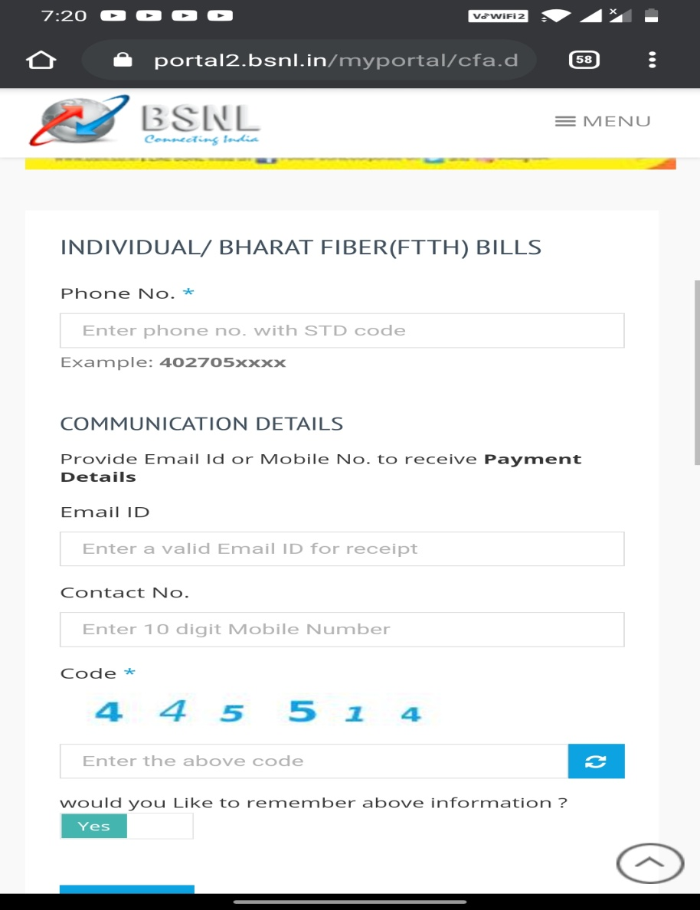

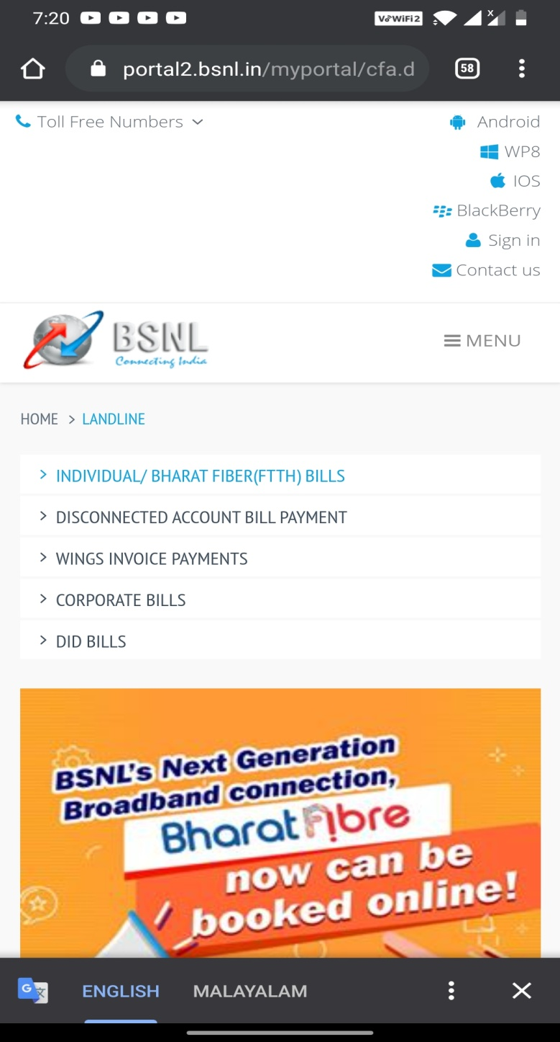

Phone Numbers

